New Member Application: 2018
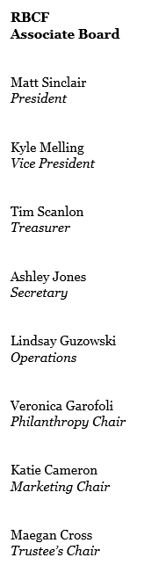

Name: Click or tap here to enter text.
Date: Click or tap to enter a date.

Why are you interested in joining the Rainbow Babies and Children’s Foundation Associate Board?
Click or tap here to enter text.

The Associate Board partners with a variety of local businesses and organizations to host events that promote the work and mission of the Rainbow Babies & Children’s Foundation along with the hospital. What event or partnership idea would you bring?
Click or tap here to enter text.

Are there any conflicts of interest that would prevent you from being fully committed to the Associate Board? If so, please describe them.
Current employees of UH and its affiliates are unable to join the Associate Board. Further, spouses or close relatives of a current employee in a key position at RBCH, UH or another health care institution (Cleveland Clinic, Akron Children’s, etc.) are unable to join the Associate Board.
Click or tap here to enter text.

Please provide one professional reference.

Name: Click or tap here to enter text.
Context: Click or tap here to enter text.
Phone: Click or tap here to enter text.
Email: Click or tap here to enter text.

